Use Case Realisation Report (Analysis) - Search Project Proposal
FOR
Volunteer Management System
(VMS)

CLIENT
PROJECT | Volunteer Management System (VMS)
TITLE | Use Case Realisation Report (Analysis) - Search Project Proposal
VERSION | 0.1a
DATE | 13-Aug-2011
 | ORIGINATOR
 | Name / Signature | Team 8S
 | APPROVAL
 | Name / Signature | Phung Kim Cuong, Dio
Institute of Systems Science |  | Document Reference
25 Heng Mui Keng Terrence  Singapore 119615 |  | VMS/T-1.4.1/13

 | Acceptance
 | Customer Signature |  | Customer Signature
 | Name & Designation |  | Name & Designation
 | Date & Company Stamp |  | Date & Company Stamp

Revision History

Date | Version | Description | Author
12-Jun-2011 | 0.1a | Creation | Team 8S
 |  | Refer to amendment history

Table of Contents

1. Brief Description 3
2. Flow of Events 3
2.1 Standard Flow 3
2.1.1 View Project Proposals: 3
2.1.2 Approve/Reject Project Proposal: 3
2.2 Exceptions 4
3. Interaction Diagrams 5
3.1 Collaboration Diagram for Review Project Proposal 5
4. Participating Objects 5
4.1 Staff 5
4.2 Project Manager 5
4.3 Date 5
4.4 Project 5
4.5 ProjectListingScreen 6
4.6 CreateProjectScreen 6
4.7 UpdateProjectScreen 6
4.8 ViewProjectScreen 6
4.9 HomeScreen 6
4.10 MainController 6
4.11 ProjectController 6
5. Class Diagrams 6
6. Derived Requirements 6
ANNEX D Amendment History 8

Use Case Realisation Report (Analysis) - Search Project Proposal

Brief Description
The use case enables a Project Coordinator to view the list of project proposal.

Flow of Events
The standard flow of events for this use case and any exceptions are described in the following subsections. See section 3.1 for an overview of the participating Actors and Domain Objects.

Standard Flow
Precondition: User has logged in the system and the user role is project coordinator
The workflow is as below:

Search Project Proposal:
- The use case starts when the Coordinator selects the menu option from the HomeScreen. The HomeScreen.getProjectProposalScreen() operation is triggered.
- The getProjectProposalScreen() operation triggers the MainController. getProjectProposalScreen() which delegates to the loadProposalList() operation of the ProposalController
- Then the ProposalController trigger the getStaffDetails() operation of the StaffController, which in turn call the getStaff() operation from the corresponding entity.
- Using the staff profile, the ProposalController triggers the getProposal() from the corresponding Proposal entity.
- Now the coordinator see the list of project proposal belongs to him, he can perform a search on the ProjectProposalListingScreen.search() method
- This method will trigger the ProposalController.searchByCriteria(), then the ProposalController return the result via ProjectProposalListingScreen showFilteredResult() operation
- The use case terminates when the user select Close button which trigger close() method on ProjectProposalListingScreen.

Exceptions
- No exception has been identified in this use case

Interaction Diagrams

Collaboration Diagram for Search Project Proposal
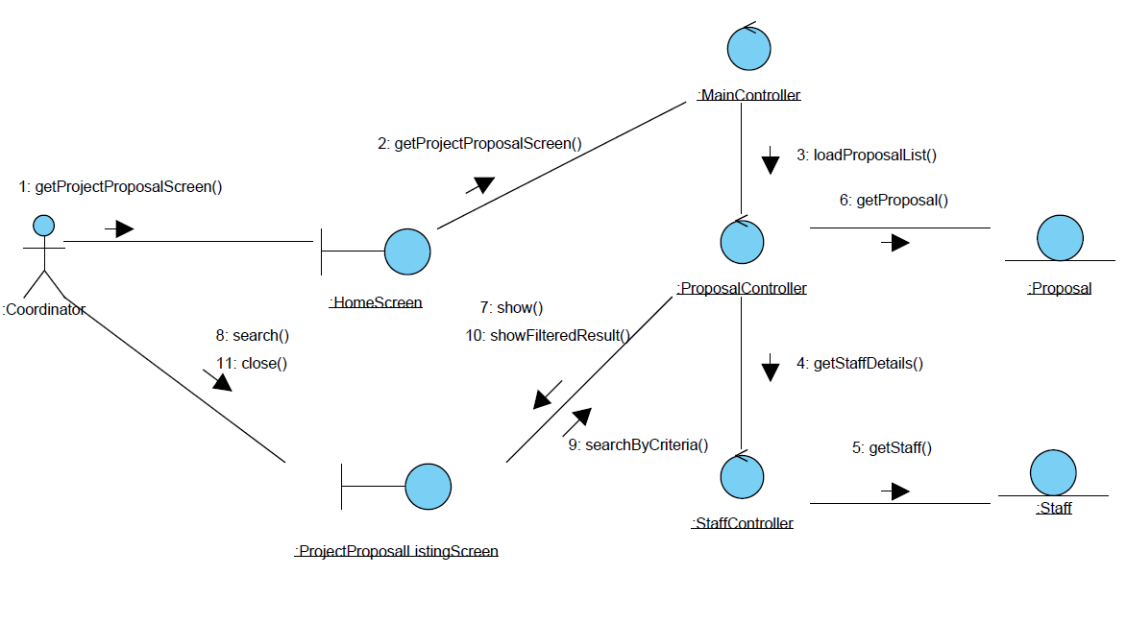
Figure 1 – Search Project Proposal

Participating Objects

Staff
This entity object stores the details concerning a staff of the volunteer organisation. The primary attribute that it holds is the userID.

Coordinator
This is an actor type which represents a user with coordinator role in the system.

Proposal
This entity object stores the details concerning a proposal of a project in the volunteer organisation. The primary attribute that it holds is the projecProposalID.

ProjectProposalListingScreen
This boundary object is used for collection of project proposal details. Coordinator actor interacts with this object.

HomeScreen
This boundary object is used for redirecting and displaying of home screen details and menu. All the user actors use this object.

MainController
This control object co-ordinates the menu selection and dispatches of requests of the volunteer management system. It delegates the user requests to the specific use case control objects for carrying out the use cases.

ProposalController
This control object co-ordinates the creation, update, viewing and searching of project proposal record in the volunteer management system. It receives requests from the boundary objects allocated for the specific purposes, along with all the necessary details required for the execution of these requests.

StaffController
This control object co-ordinates the creation, update, viewing and searching of staff record in the volunteer management system. In this use case it is used to get a profile of a logged-in user.

Class Diagrams

Derived Requirements
The Staff office PC (client system), keyboard and mouse will be used to process the project details and view all the system responses.

ANNEX D Amendment History

This is a record of all amendments made to the Document.
Version | Chapter / Section | Page No | Notes of Amendments or Changes

